**S Abhishek AM.EN.U4CSE19147**

**Labsheet – 7**

**1. Write a C program that allows communication between a parent process and child process using Shared Memory.**

**Parent process has to take input n from the user, where n is an integer.**

**The parent process should then write n to the shared memory.**

**The child process has to read the contents of the shared memory and then print all the odd numbers till the limit n.**

#include<stdio.h>

#include<sys/ipc.h>

#include<sys/shm.h>

#include<unistd.h>

#include<sys/wait.h>

int main()

{

int shmid;

shmid = shmget(IPC_PRIVATE, sizeof(int), 0777|IPC_CREAT);

if (fork() == 0)

{

int *a;

a = (int *) shmat(shmid, 0, 0);

sleep(4);

printf("Child reads: %d\n",a[0]);

printf("All odd numbers till %d : ",a[0]);

for(int i=1;i<=a[0];i++)

{

if(i%2!=0)

{

printf("%d ",i);

}

}

shmdt(a);

}

else

{

int *a;

a = (int *) shmat(shmid, 0, 0);

printf("Enter the Number : ");

int i;

scanf("%d",&i);

a[0] = i;

printf("Parent writes: %d\n",a[0]);

wait(NULL);

shmdt(a);

shmctl(shmid, IPC_RMID, 0);

}

}

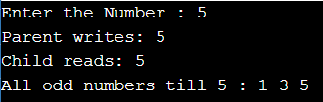

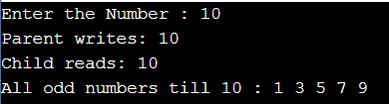

**2. Write a C program that allows communication between a parent process and child process using shared memory**

**a. Parent process has to take input string from the user.**

**b. The child process has to read the contents of the shared memory and convert it to capital letters and print it.**

#include<stdio.h>

#include<sys/ipc.h>

#include<sys/shm.h>

#include<unistd.h>

#include<sys/wait.h>

int main()

{

int shmid;

shmid = shmget(IPC_PRIVATE, sizeof(char), 0777|IPC_CREAT);

if (fork() == 0)

{

char *a;

a = (char *) shmat(shmid, 0, 0);

sleep(5);

printf("Child reads: %s\n",a);

for(int i=0; a[i]!='\0'; i++)

{

if(a[i]>='a' && a[i]<='z')

{

a[i] = a[i] - 32;

}

}

printf("Upper Case : %s",a);

shmdt(a);

}

else

{

char *a;

a = (char *) shmat(shmid, 0, 0);

printf("Enter the String : ");

scanf("%s",a);

printf("Parent writes: %s\n",a);

wait(NULL);

shmdt(a);

shmctl(shmid, IPC_RMID, 0);

}

}

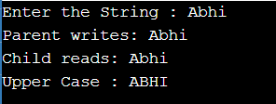

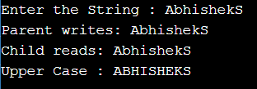

**3. Write a program that creates a shared memory segment and waits until two other separate processes writes something into that shared memory segment after which it prints what is written in shared memory.**

**For the communication between the processes to take place assume that the process 1 writes 1 in first position of shared memory and waits;**

**process 2 writes 2 in first position of shared memory and goes on to write 'hello' and then process 3 writes 3 in first position of shared memory and goes on to write 'memory' and finally the process 1 prints what is in shared memory written by two other processes.**

#include <stdio.h>

#include <sys/ipc.h>

#include <sys/shm.h>

#include <unistd.h>

#include <string.h>

#include <ctype.h>

#include<sys/wait.h>

int main()

{

int shmid;

int *a, *b, *c;

int i=0, n;

shmid = shmget(IPC_PRIVATE, sizeof(int), 0777|IPC_CREAT);

b = (int *)shmat(shmid, 0, 0);

b[0]=1;

if(!fork())

{

c = (int *)shmat(shmid, 0, 0);

c[0] = 2;

printf("Hello\n");

shmdt(c);

if(!fork())

{

a = (int *)shmat(shmid, 0, 0);

a[0]=3;

printf("Memory\n");

shmdt(a);

}

}

else

{

wait(NULL);

printf("%d\n",b[0]);

shmdt(b);

}

shmctl(shmid, IPC_RMID, 0);

}

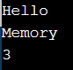

**4. Write a c program [using shared memory] to find average of square of numbers supplied by a user using 3 processes. 1 parent and two children. [Without buffer]**

**Parent should continuously take integers as input from the user until a special character, square it and supply it to both children.**

**Child #1 should find sum of these numbers, send it to the parent and exit.**

**Child #2 should count these numbers, send it to the parent and exit**

**Parent on getting response from both the children should find mean of square of numbers supplied by the user by dividing the child #1's result with child 2's and give it to the user.**

#include<stdio.h>

#include<unistd.h>

#include<string.h>

#include<ctype.h>

#include<stdlib.h>

#include <sys/ipc.h>

#include <sys/shm.h>

#include<sys/wait.h>

int main()

{

int shmid,*arr,index=2,f=0;

char str[10];

shmid = shmget(IPC_PRIVATE, 100*sizeof(int), 0777|IPC_CREAT);

arr = (int *)shmat(shmid, 0, 0);

printf("PID --> %d and PPID --> %d\n",getpid(),getppid());

while(1)

{

printf("Enter the number : ");

scanf ("%s", str);

int len = strlen (str);

for (int i=0;i<len; i++)

{

if (!isdigit(str[i]))

{

f = 1;

break;

}

}

if (f == 1)

{

printf("Oops!!..Special Character Found!\n\n");

break;

}

int x = atoi(str);

arr[index] = x*x;

index++;

}

if(fork())

{

if(!fork())

{

int sum=0,i=2;

arr = (int *)shmat(shmid, 0, 0);

printf("\nPID --> %d and PPID --> %d.",getpid(),getppid());

printf("\nNumbers to be added are : ");

while(arr[i])

{

sum = sum+arr[i];

printf("%d ",arr[i]);

i++;

}

arr[0] = sum;

}

else

{

wait(NULL);

printf("\n\nPID --> %d and PPID --> %d.\n",getpid(),getppid());

printf("Mean of Square of Numbers is %.2f.",(float)arr[0]/arr[1]);

shmdt(arr);

shmctl(shmid, IPC_RMID, 0);

}

}

else

{

int count=2;

arr = (int *)shmat(shmid, 0, 0);

while(arr[count])

{

count++;

}

arr[1] = count;

printf("PID --> %d and PPID --> %d.\n",getpid(),getppid());

printf("Count is %d\n",count);

shmdt(arr);

} }

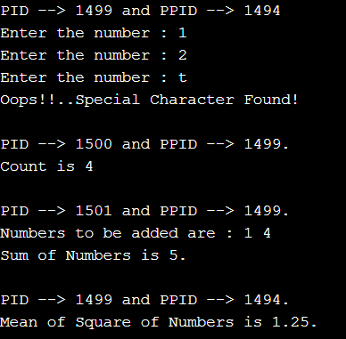

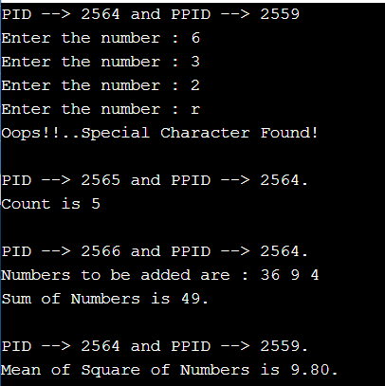

**One Drive :** [**Click Me!!**](https://amritauniv-my.sharepoint.com/:f:/g/personal/sabhishek_am_students_amrita_edu/EgZJDwiOXDNEskNf4NlQvHwBaEINgzKWFzK6zGn2BuzSrg?e=pJIExs)

**Thankyou!**